GWAS Analysis:

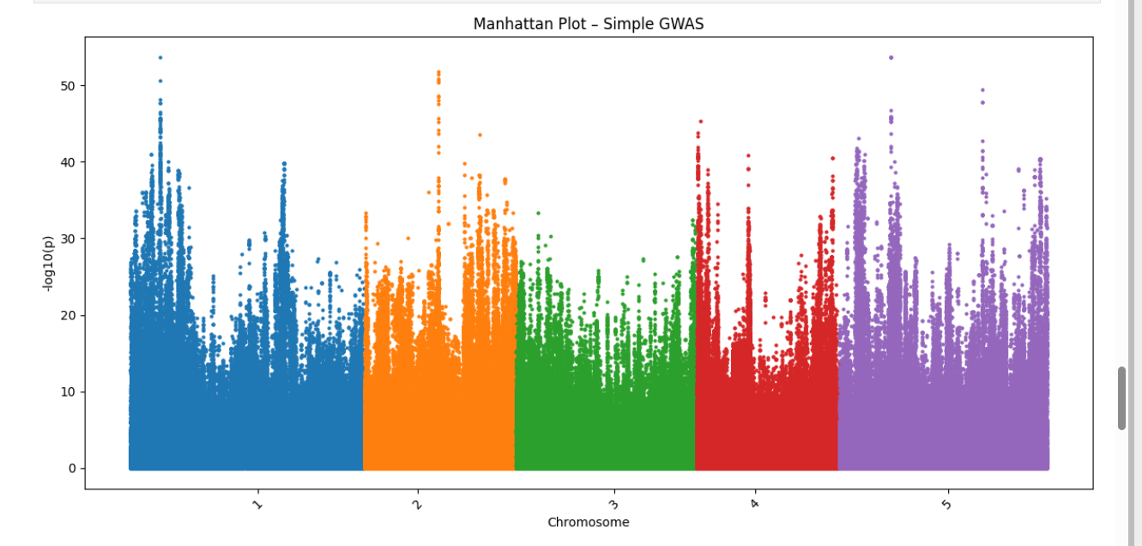

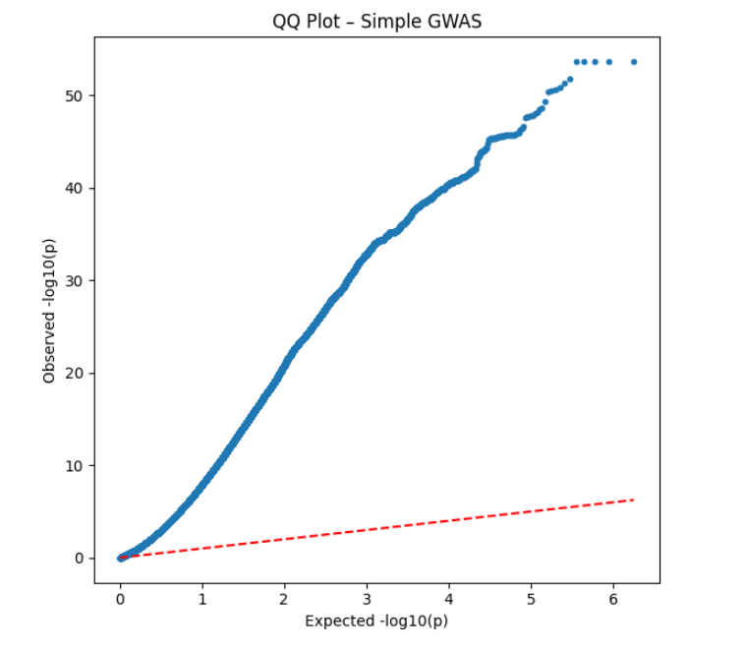

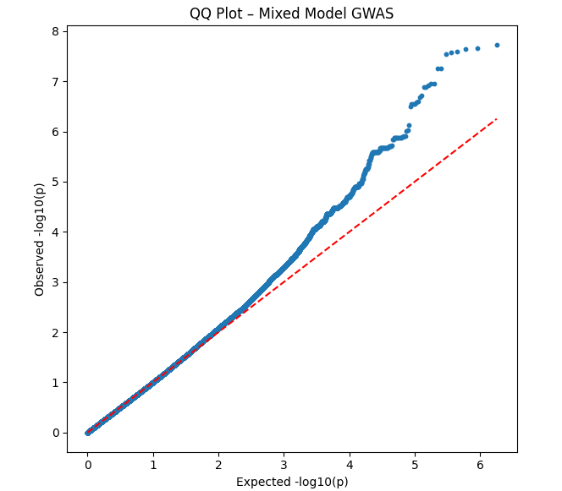

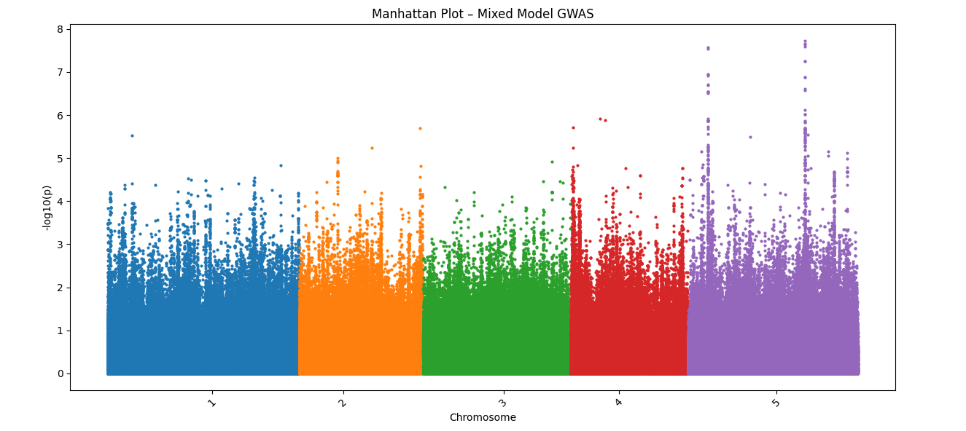

- The simple GWAS analysis with a higher log score has more significant SNPs. They are false positives because the population structure is not correct.

- In the simple GWAS QQ plots, we can see a huge deviation from the red line, which means many false positives.

In mixed model GWAS, the deviation is less from the red line as compared to the single GWAS model. There are some significant peaks in chromosome 5.

